**Functions Part 1 Challenge-The Karel Robot**

Open this site.

<https://stanford.edu/~cpiech/karel/ide.html>

set world 5x5

/**

* Welcome to the Stanford Karel IDE.

* This is a free space for you to

* write any Karel program you want.

**/

function main(){

goInCircle();

goInCircle();

}

//Function

function goInCircle(){

move();

turnLeft();

move();

turnLeft();

}

//See reference on right side top

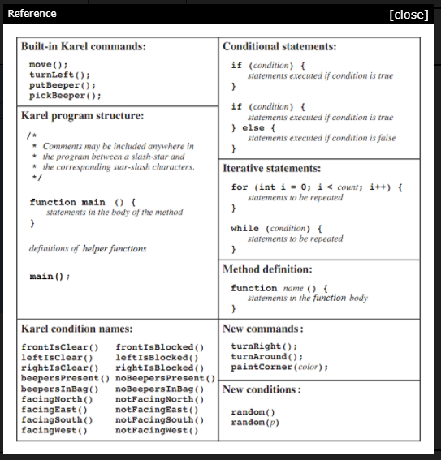

/**

* Welcome to the Stanford Karel IDE.

* This is a free space for you to

* write any Karel program you want.

**/

function main(){

moveFourTimes();

turnLeft();

moveFourTimes();

}

//Function

function moveFourTimes(){

move();

move();

move();

move();

}

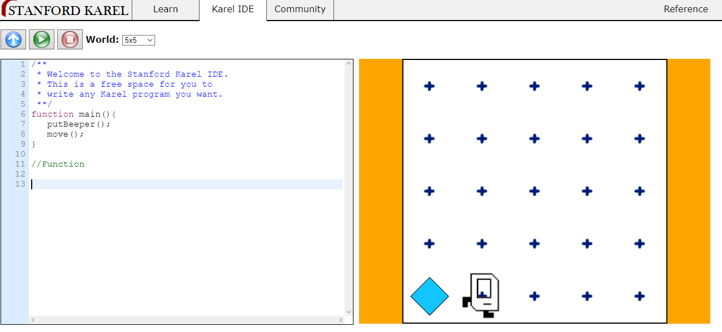

/**

* Welcome to the Stanford Karel IDE.

* This is a free space for you to

* write any Karel program you want.

**/

function main(){

putBeeper();

move();

}

/**

* Welcome to the Stanford Karel IDE.

* This is a free space for you to

* write any Karel program you want.

**/

function main(){

diagonalMoveAndBeeper();

diagonalMoveAndBeeper();

diagonalMoveAndBeeper();

diagonalMoveAndBeeper();

}

//Function

function diagonalMoveAndBeeper(){

move();

turnLeft();

move();

putBeeper();

turnRight();

}

/**

* Welcome to the Stanford Karel IDE.

* This is a free space for you to

* write any Karel program you want.

**/

function main(){

putBeeper();

diagonalMoveAndBeeper();

diagonalMoveAndBeeper();

diagonalMoveAndBeeper();

diagonalMoveAndBeeper();

}

//Function

function diagonalMoveAndBeeper(){

move();

turnLeft();

move();

putBeeper();

turnRight();

}

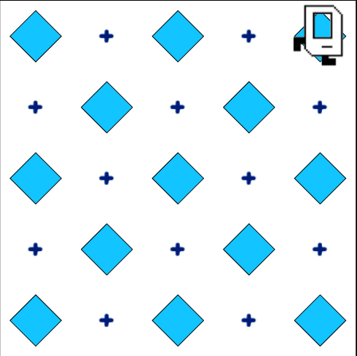

Solve above challenge

**Solution:**

/**

* Welcome to the Stanford Karel IDE.

* This is a free space for you to

* write any Karel program you want.

**/

function main(){

beepersRight();

goUpTurnLeft();

beepersLeft();

goUpTurnRight();

beepersRight();

goUpTurnLeft();

beepersLeft();

goUpTurnRight();

beepersRight();

}

function goUpTurnRight() {

turnRight();

move();

turnRight();

}

function goUpTurnLeft() {

turnLeft();

move();

turnLeft();

}

function beepersRight() {

putBeeper();

move();

move();

putBeeper();

move();

move();

putBeeper();

}

function beepersLeft() {

move();

putBeeper();

move();

move();

putBeeper();

move();

}